NAAN MUDHALVAN REPORT ON
DOC GENIE
This report is submitted to the Manonmaniam Sundaranar University, Tirunelveli.
In partial fulfillment of the requirements for the degree of
BACHELOR OF SCIENCE IN COMPUTER SCIENCE
Submitted by,
BEJON V(REG NO:23083011802111018)
REJITH R (REG NO:23083011802111031)
AJIN L S (REG NO:23083011802111009)
ASWIN T (REG NO:23083011802111016)
RAGUL R S (REG NO:23083011802111030)
Under the Guidance of
Dr. P.M. Jogi Priya M.C.A, M.Phil, M.Tech, Ph.D.
(Asst. Prof. Dept of Computer Science)

DEPARTMENT OF COMPUTER SCIENCE
ANNAI VELANKANNI COLLEGE
Accredited with ‘A’ Grade by NAAC (II Cycle)
(AFFILIATED TO MANONMANIAM SUNDARANAR UNIVERSITY, TIRUNELVELI) THOLAYAVATTAM-629157 KANYAKUMARI DISTRICT, TAMILNADU, Ph:04651-235270, Website: www.annaicollege.edu.in
Doc-Genie
Professional Python Function Docstring Generator with AST Analysis

Project Description
Modern software development demands well-documented code for maintainability, readability, and collaboration. However, developers often skip writing proper docstrings due to time constraints, oversight, or lack of standardization. This leads to poorly documented Python codebases, making them difficult to understand, maintain, and scale.

Existing documentation tools mainly generate external documentation but do not intelligently create meaningful function-level docstrings by understanding the code structure. There is a need for an automated system that can analyze Python source code and generate accurate, standardized docstrings.

Design and develop DocGenic, an automated Python tool that uses Abstract Syntax Tree (AST) analysis to examine Python functions and generate professional, context-aware docstrings following standard formats (such as Google, NumPy, or reStructuredText). The system should intelligently extract function signatures, parameters, return types, and basic behavior patterns to produce human-readable documentation.

Scenarios
Scenario 1: Legacy Code Documentation

Many software organizations maintain large Python codebases that have evolved over years. In these legacy systems, developers often neglected to write proper docstrings or documentation. As a result:
- Understanding old functions becomes time-consuming
- Onboarding new developers is difficult
- Code maintenance and debugging are error-prone
- Technical debt keeps increasing
To solve this problem, DocGenie, a professional Python function docstring generator powered by AST (Abstract Syntax Tree) analysis, is introduced.

Scenario 2:
API Development & Documentation
Modern software systems heavily rely on APIs for communication between services. In fast-paced development environments, developers often focus on functionality first and postpone writing proper API documentation. Over time, this leads to poorly documented endpoints that are difficult to understand and maintain.
To address this challenge, DocGenie, a professional Python function docstring generator powered by AST analysis, is integrated into the API development workflow to automatically generate.

Scenario 3:
Team Collaboration & Standards
In modern software teams, multiple developers contribute to the same Python codebase. Each developer may follow a different documentation style—or skip documentation entirely. Over time, this leads to inconsistent docstrings, reduced readability, and confusion during collaboration.
To ensure uniform documentation practices across the team, DocGenie, a professional Python function docstring generator powered by AST analysis, is introduced as a standardization tool in the development workflow.

Scenario 4:
Educational & Training Purpose
In academic environments and coding bootcamps, students often focus on writing functional Python code but neglect proper documentation practices. As a result, beginners struggle to understand the importance of docstrings, code readability, and professional coding standards.
To bridge this gap, DocGenie, a professional Python function docstring generator powered by AST analysis, is introduced as an educational support tool that helps students learn correct documentation practices automatically.
Scenario 5:
Code Review & Quality Assurance
In professional software development, code review is a critical step to ensure code quality, readability, and maintainability. However, reviewers often spend significant time checking for missing or poorly written docstrings instead of focusing on core logic and design.
To streamline the review process and enforce documentation standards automatically, DocGenie, a professional Python function docstring generator powered by AST analysis, is integrated into the quality assurance workflow.

Architecture Overview
Doc-Genie is a document processing system built using Python that helps users upload, analyze, and retrieve information from documents easily. The architecture mainly consists of a user interface layer, application layer, processing layer, and storage layer. In the user interface layer, users interact with the system through a web interface where they can upload documents and ask questions about the content.The processing layer performs tasks like document parsing, text extraction, natural language processing (NLP), and information retrieval using Python libraries such as PyPDF, NLTK, or spaCy. This layer analyzes the document content and generates meaningful responses for the user. Finally, the storage layer stores uploaded documents and processed data using databases or file storage systems. Overall, the Doc-Genie architecture ensures efficient document management, quick search, and intelligent information extraction using Python technologies.

Core Technologies

- Python Programming Language
Python is the main programming language used to develop Doc-Genie because it is simple, powerful, and supports many libraries for data processing and artificial intelligence.
- Web Framework (Flask / Django)
Frameworks like Flask or Django are used to build the backend of the application. They handle user requests, manage APIs, and connect the user interface with the processing system.
- Document Processing Libraries
Libraries such as PyPDF2, pdfplumber, or python-docx are used to read and extract text from documents like PDF and Word files.
- Natural Language Processing (NLP)
NLP libraries such as NLTK and spaCy help the system understand and analyze the text in documents. They are used for tasks like tokenization, keyword extraction, and text analysis.
- Machine Learning / AI Models
Machine learning models help Doc-Genie understand user queries and retrieve relevant information from documents. Libraries like scikit-learn or AI frameworks may be used for this purpose.

Pre-requisites
Software Requirements
To develop the Doc-Genie system using Python, the following software components are required:
Operating System:
The system should run on an operating system such as Windows, Linux, or macOS.
Programming Language:
The main programming language used for developing the application is Python.
Code Editor / IDE
A development environment is required to write and manage the code. Common tools include:
Visual Studio Code
PyCharm
Jupyter Notebook
Python Libraries
Several libraries are needed for document processing and data handling:
NumPy – for numerical operations
Pandas – for data manipulation
PyPDF2 – to read and process PDF files
python-docx – to create and edit Word files
Database Software (Optional)
To store documents and related data, a database like MySQL or SQLite can be used.
Web Framework (Optional)
If the system is web-based, frameworks such as Flask or Django can be used to build the interface.
Knowledge Prerequisites
To develop the Doc-Genie system using Python, the developer should have the following basic knowledge:
- Basic Python Programming
Understanding Python concepts such as variables, data types, loops, functions, anfilehandling is necessary to build the application.
- Object-Oriented Programming (OOP)
Knowledge of classes, objects, inheritance, and methods helps in designing the structure of the Doc-Genie system.
- File and Document Handling
Basic knowledge of working with document formats like PDF, DOCX, and TXT using Python libraries such as PyPDF2 and python-docx.
- Data Handling and Analysis
Understanding how to manage and process data using libraries like Pandas.
- Basic Database Knowledge
Knowledge of storing and retrieving data using databases like MySQL or SQLite.
- Basic Web Development (Optional)
If the system includes a web interface, knowledge of HTML and Python web frameworks like Flask or Django is helpful.
Hardware Requirements
To develop and run the Doc-Genie system using Python, the following hardware components are required:
- Processor
A computer with a minimum Intel Core i3 processor or higher is recommended for smooth execution of the application.
- RAM (Memory)
At least 4 GB RAM is required. For better performance while processing large documents, 8 GB RAM is recommended.
- Storage (Hard Disk / SSD)
Minimum 50 GB free storage space is required to store the software, libraries, and generated documents.
- Display Monitor
A standard monitor with good resolution is required for developing and testing the application.
- Input Devices
Keyboard and mouse are required for coding, navigation, and managing documents.
- Internet Connection
A stable internet connection is useful for installing Python libraries, updates, and accessing online resources.

2. Multi-Style Docstring Support
Allow users to choose different documentation styles.
Supported formats
Google Style
NumPy Style
reStructuredText (reST)
Markdown documentation
Benefit:
Compatible with different documentation tools like Sphinx.
3. IDE Integration
Create plugins for popular development environments.
Possible IDE integrations
VS Code Extension
PyCharm Plugin
Jupyter Notebook integration
Features:
Auto generate docstring with shortcut
Real-time documentation suggestions

4. Automatic Code Example Generation
Doc_Genie can generate usage examples for functions.
Example:
result = add_numbers(5, 3)
print(result) # Output: 8
Benefit:
Helps beginners understand the function quickly.

5. Documentation Quality Analyzer
Add a module to evaluate documentation quality.
Checks may include:
Missing parameter descriptions
Incomplete return descriptions
Poor naming conventions
Benefit:
Improves code quality during code reviews.

6. Batch Project Analysis
Allow Doc_Genie to scan an entire project folder.
Features:
Analyze multiple Python files
Generate docstrings automatically
Create documentation reports

7. Documentation Coverage Report
Add a coverage system similar to test coverage.
Example output:
Total Functions: 120
Documented: 85
Missing Docstrings: 35
Coverage: 70%
8. Web Dashboard Interface
Develop a web-based UI for documentation management.
Features:
Upload Python files
Generate docstrings
Edit generated documentation
Export documentation
Possible tools:
Gradio
Streamlit
Flask

9. CI/CD Integration
Integrate Doc_Genie with DevOps pipelines.
Examples:
GitHub Actions
GitLab CI
Jenkins
Purpose
Automatically check documentation during builds.
10. Multi-Language Support
Extend the tool to support additional programming languages.
Future support:
Java
JavaScript
C++
Go
11. Visualization of Function Structure
Create AST visualizations.
Example:
Function dependency graphs
Call hierarchy diagrams
Libraries:
Graphviz
NetworkX
12. Documentation Export System
Allow exporting documentation to different formats.
Formats:
PDF
HTML
Markdown
API documentation
Tools:
Sphinx
MkDocs

Create requirements.txt with the following dependencies:

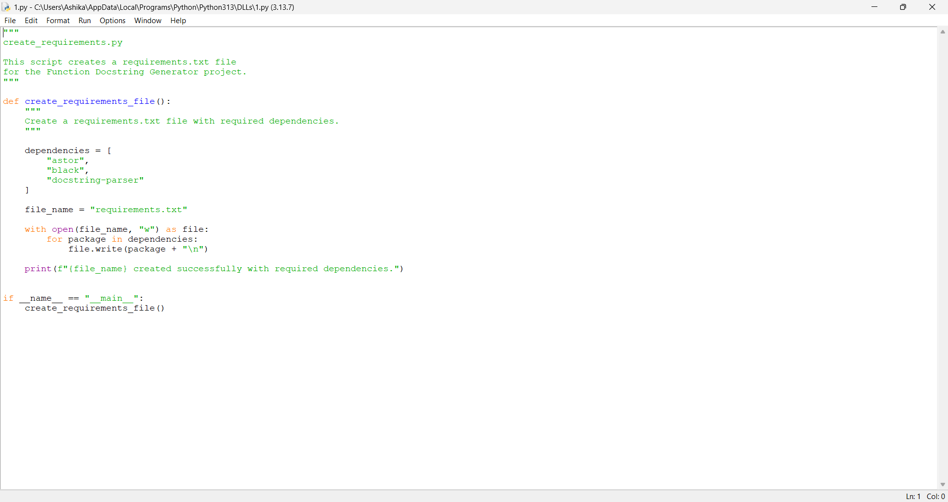
Instialize core analyzer class:

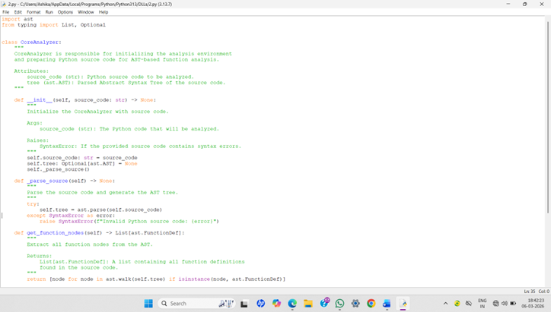
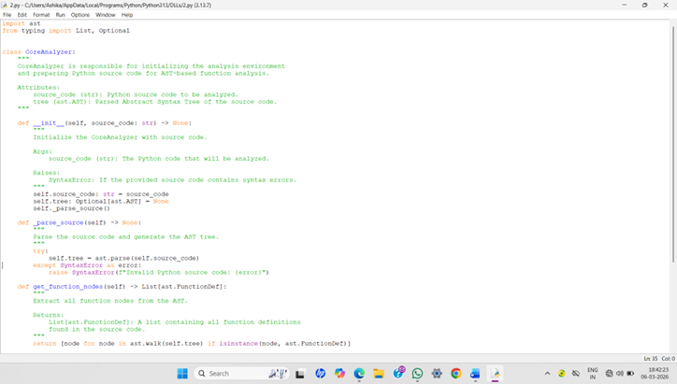
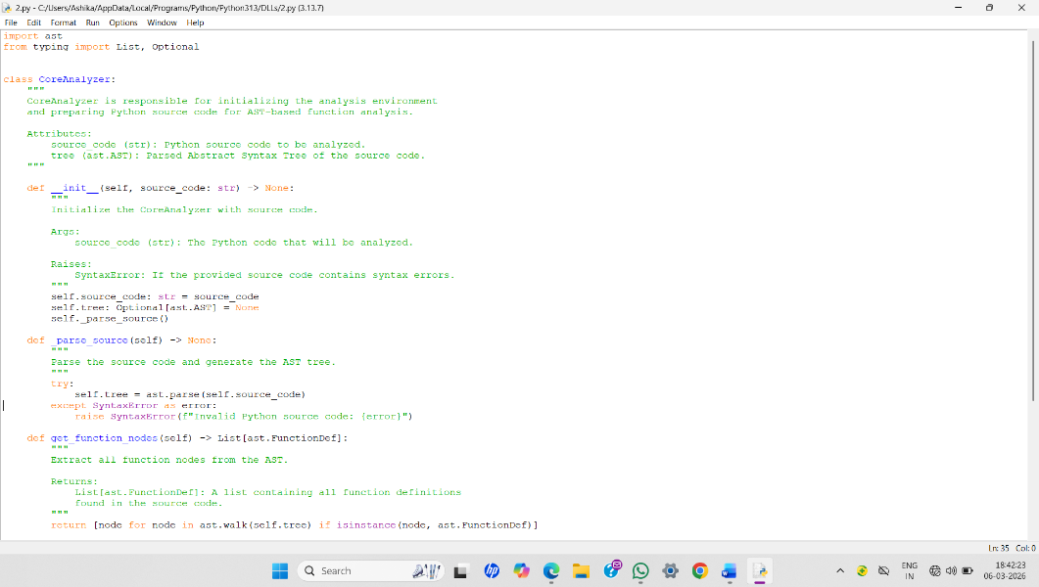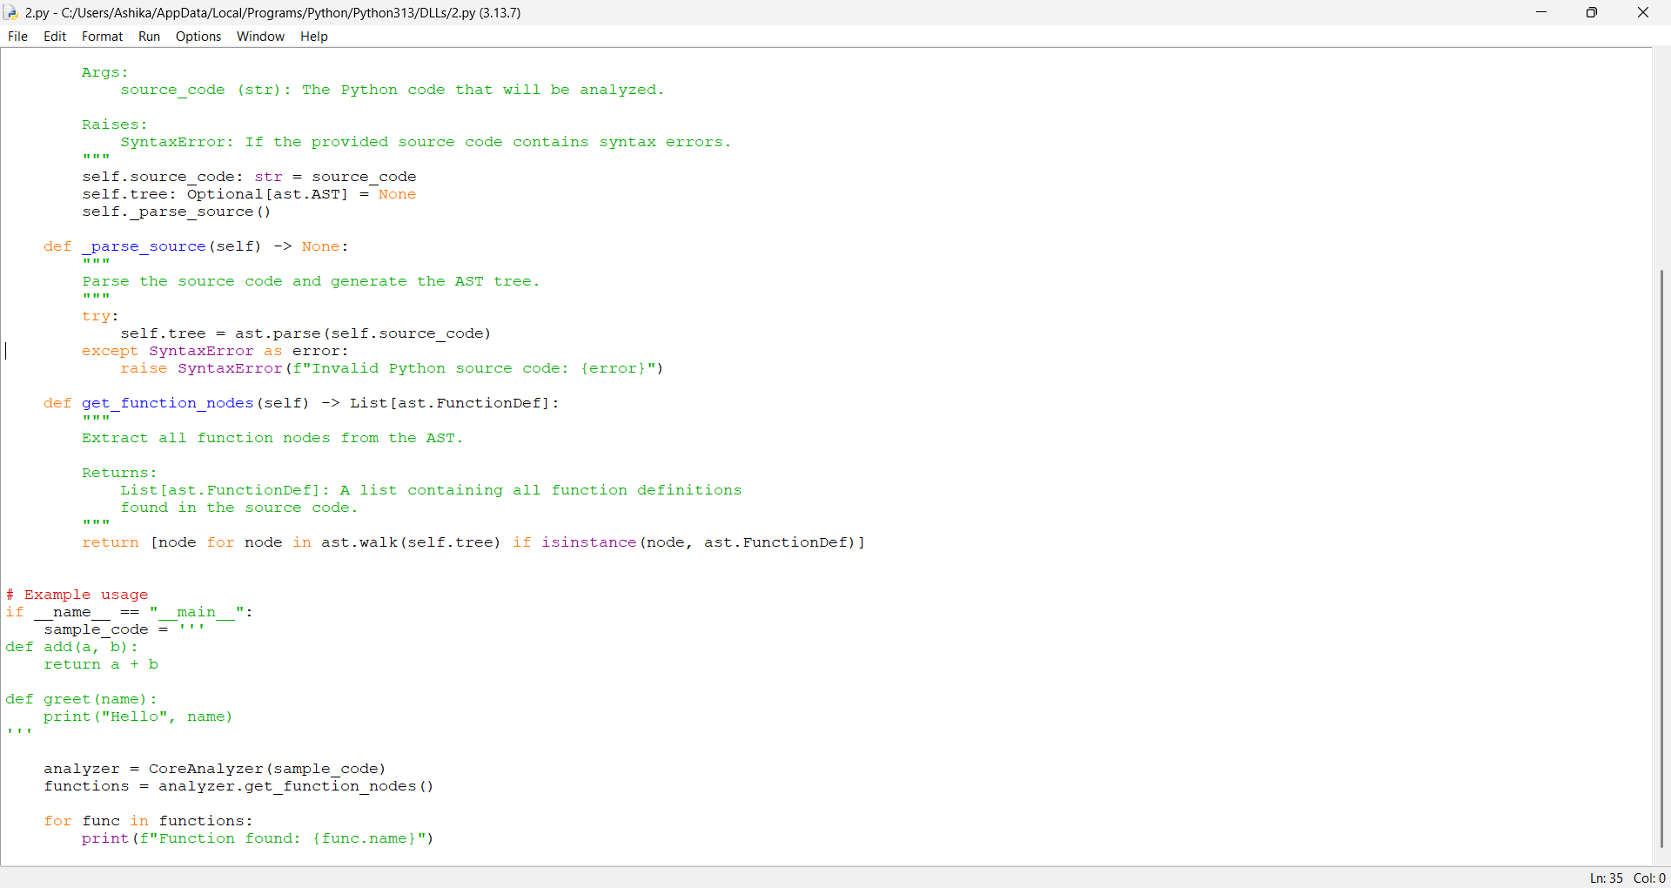

Function signature Extraction:
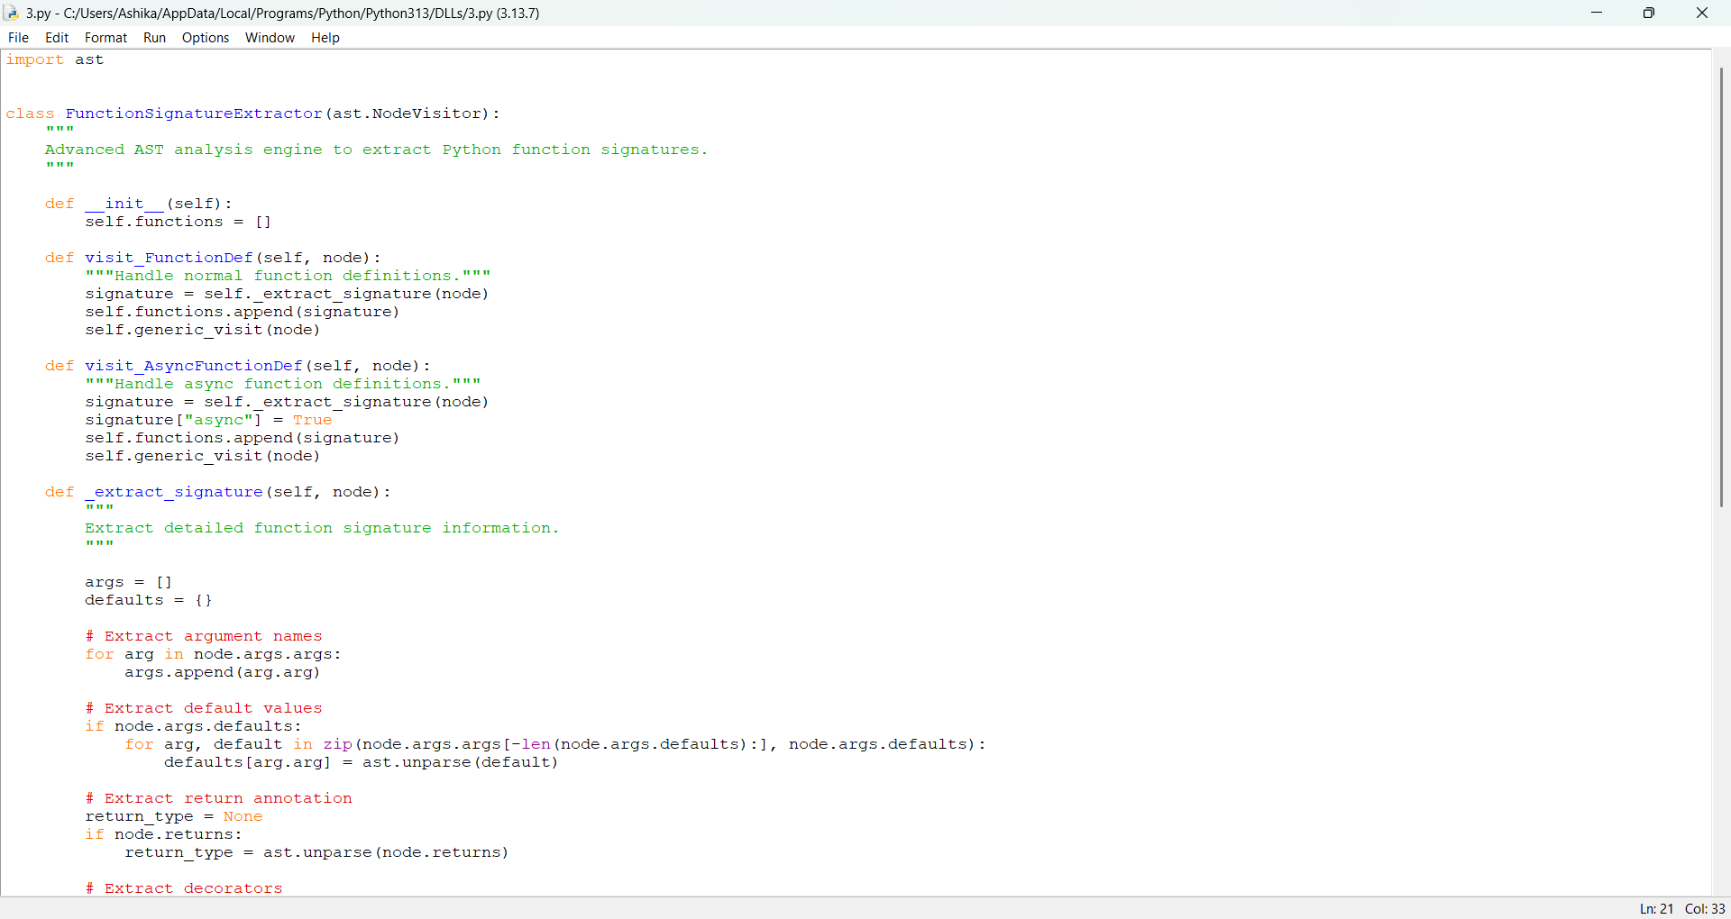
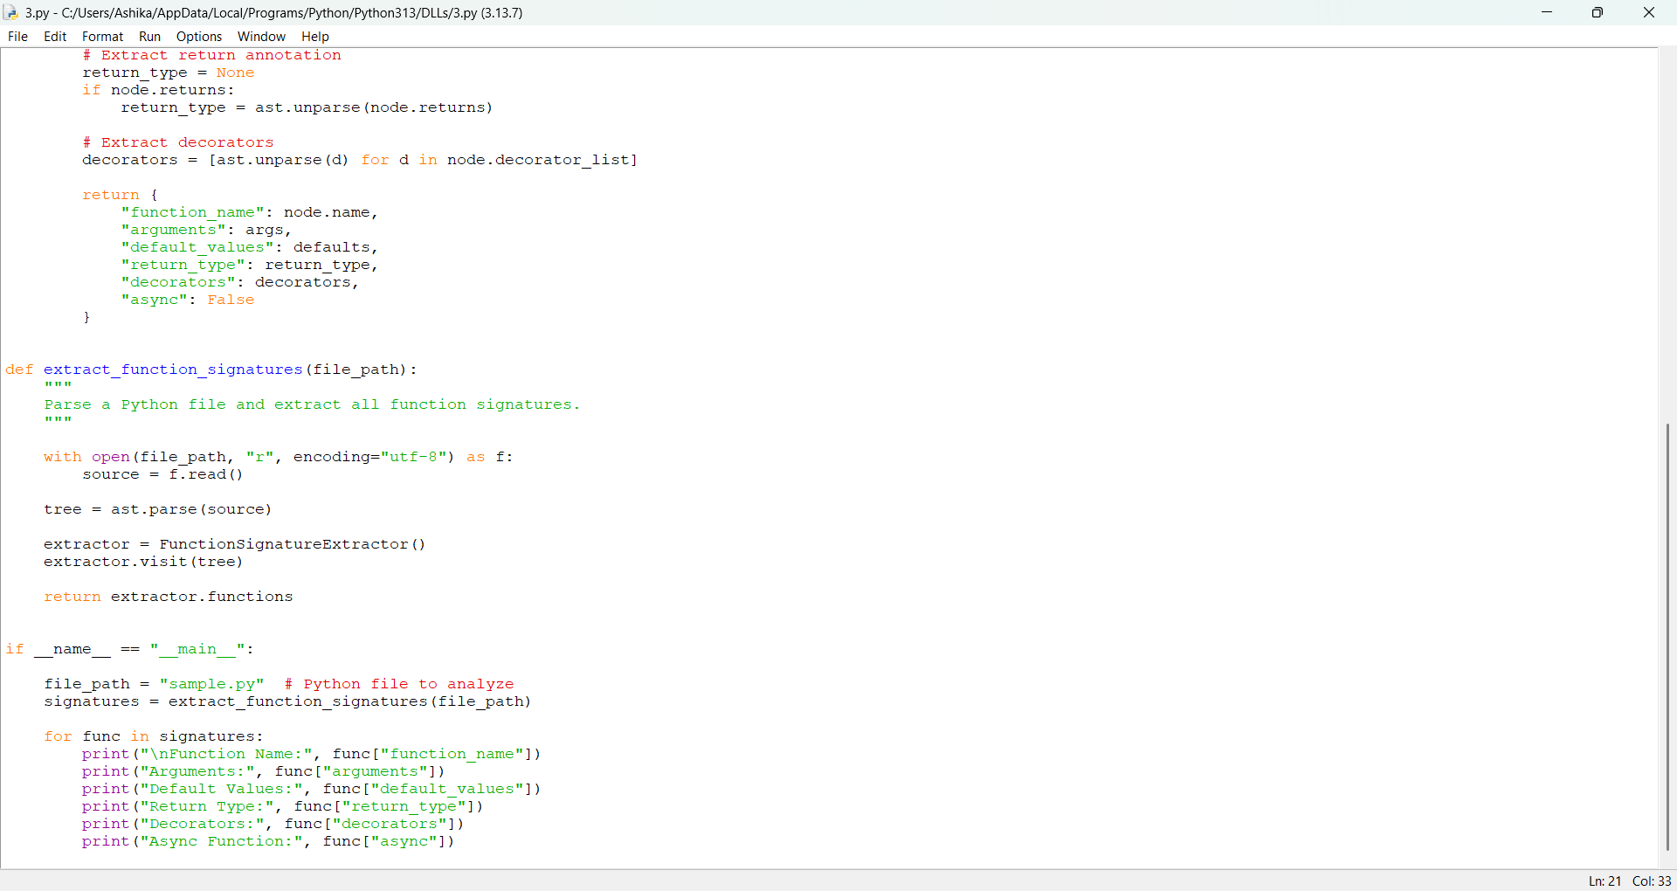

Deep logic analysis
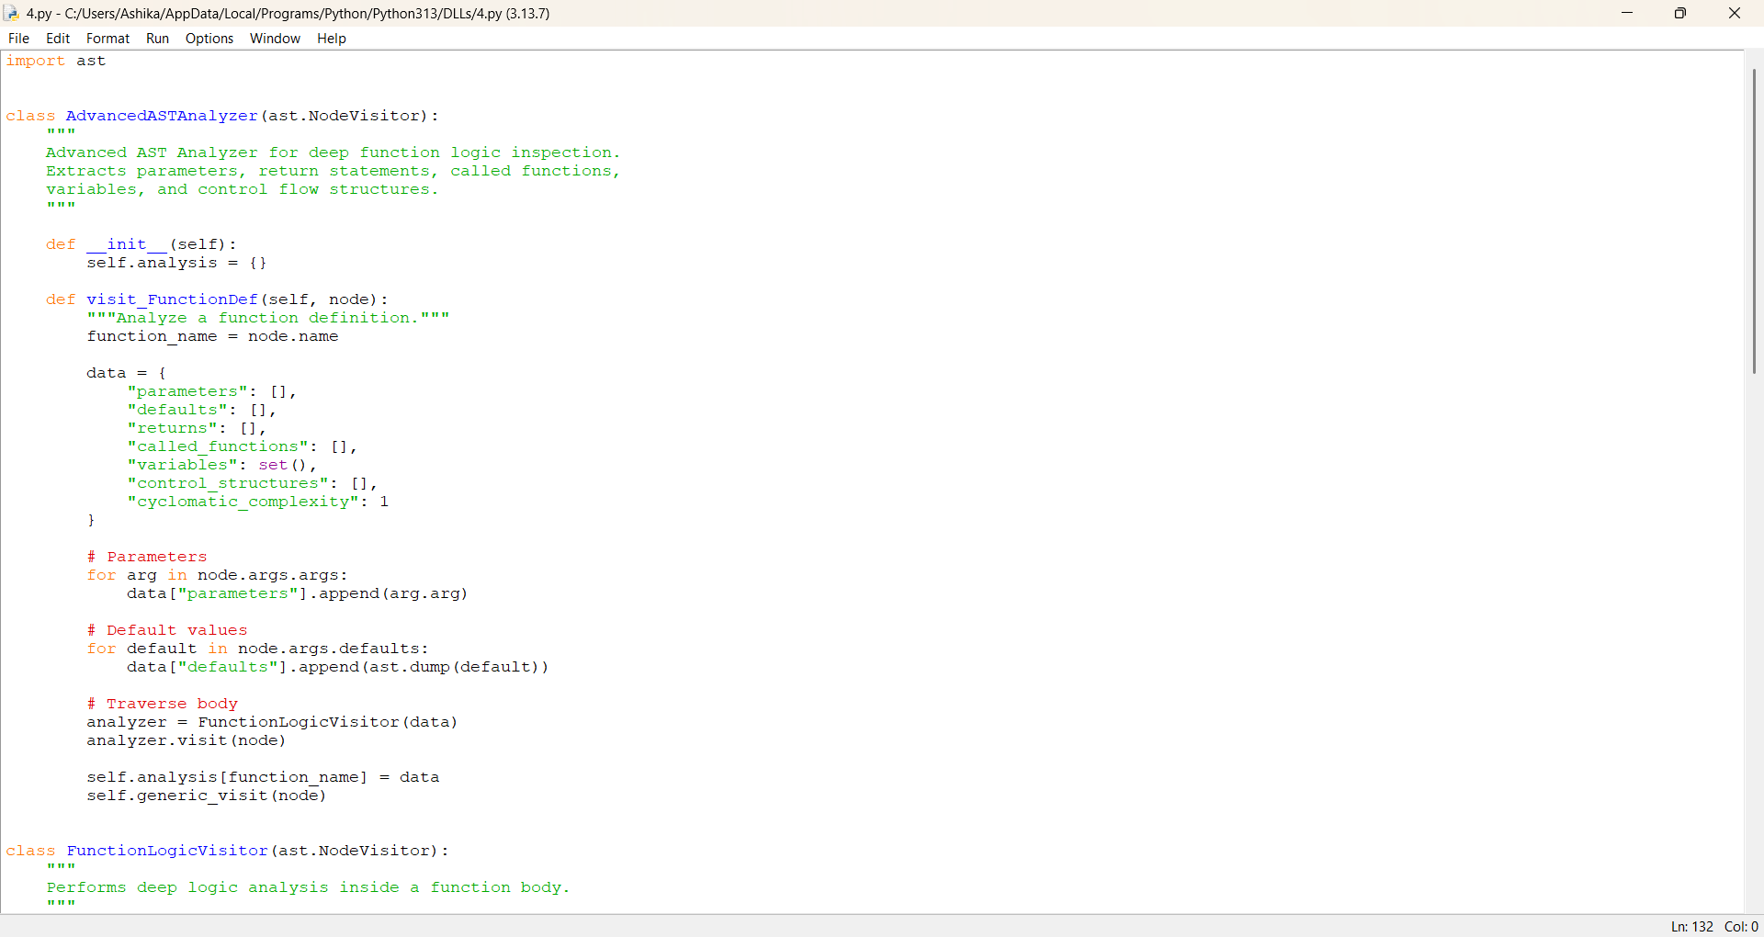

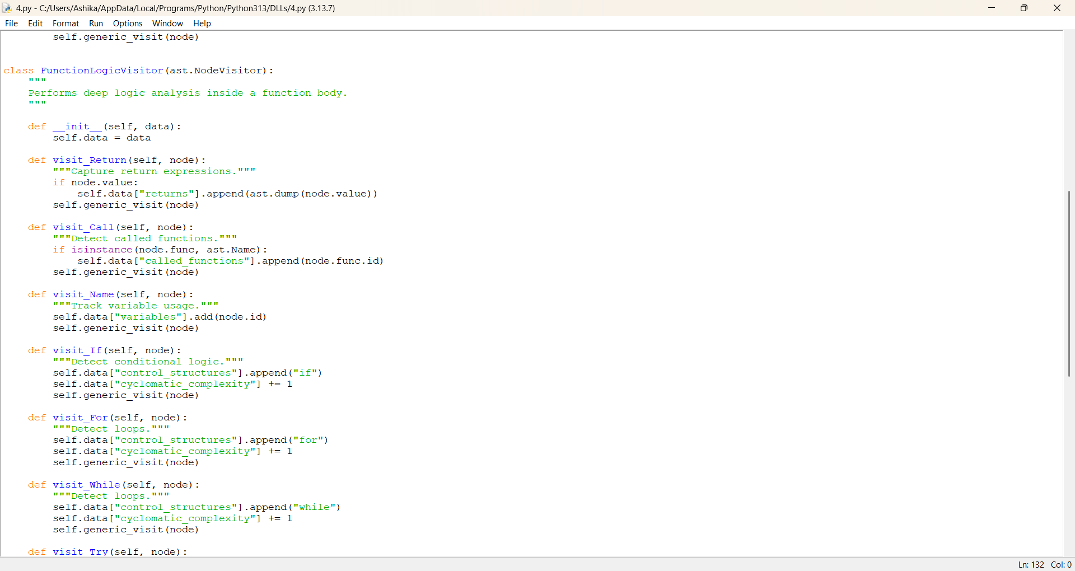

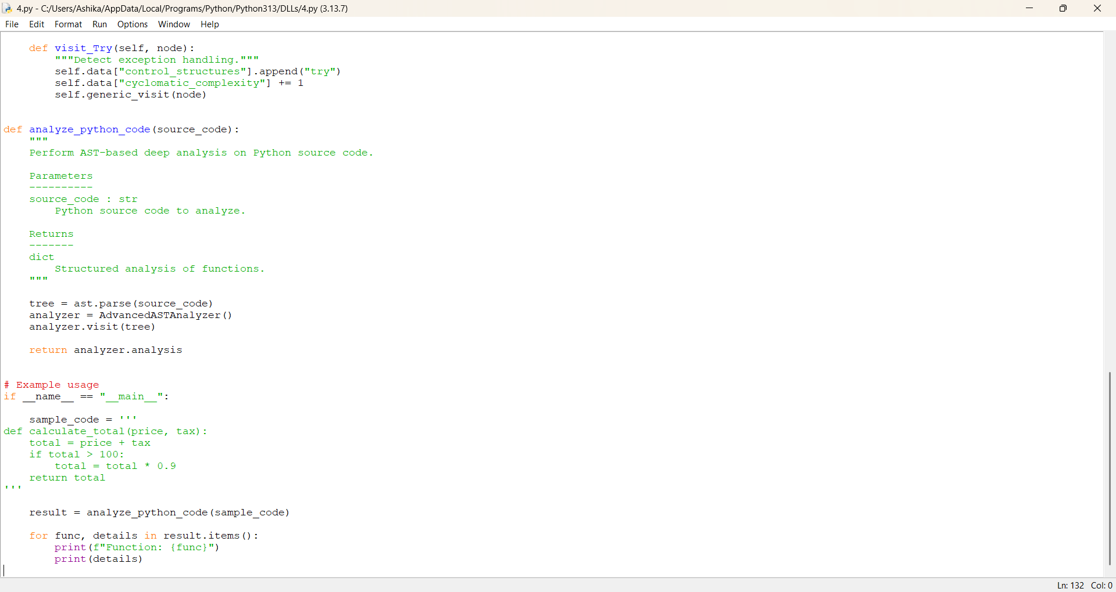

Google—style Docstring Generation:

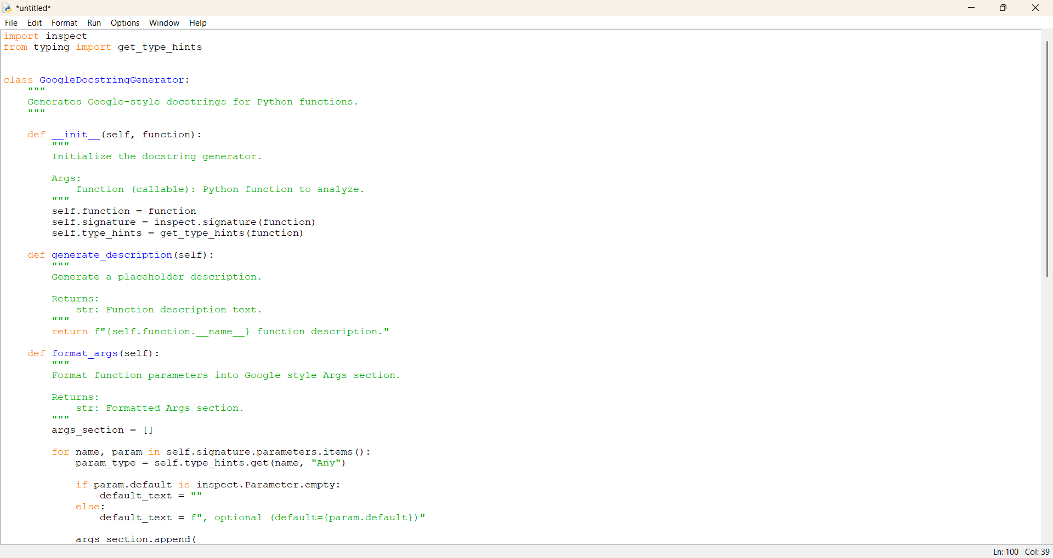

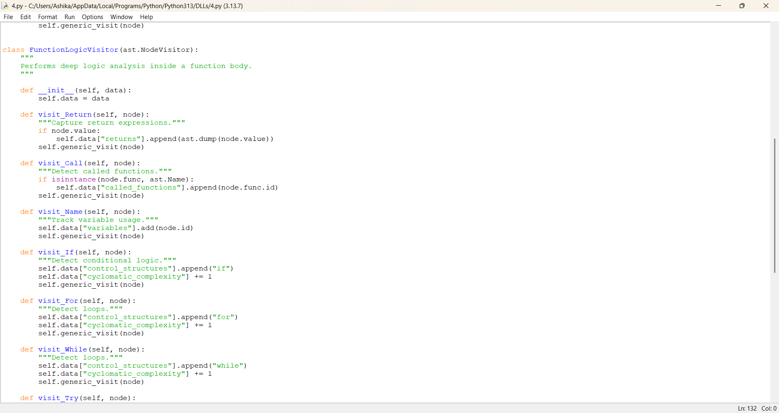



Interface components overview:

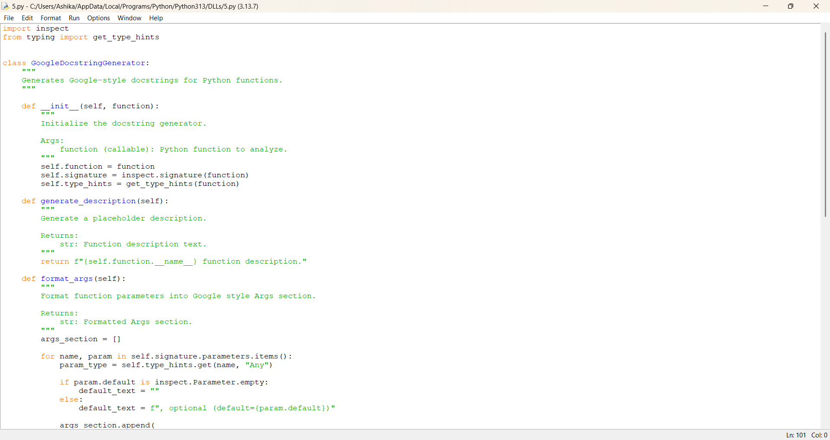

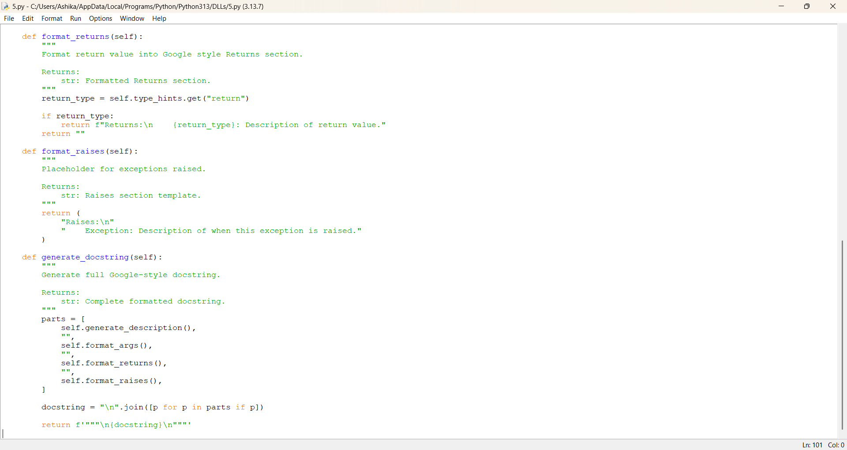

Future Enhancement:
AI-Powered Smart Docstring Generation, Multi-style Docstring Support, IDE integration, Automatic code example generation, Documentation Quality Analyzer, Batch project Analysis, Documentation coverage report, web Dashboard interface, CI/CD integration, Multi-Language support, Visualization of function structure, Documentation Export System.

Conclusion
Doc-Genie project was developed to simplify and automate the process of generation python function docstrings using Abstract Syntax Tree(AST) analysis. Writing proper documentation, but many developers often skip it because it takes times and efforts. This project helps solve that problem by automatically analyzing Python code and generating well-structured docstrings.

